Residents planning on using the following routes should expect delays on Saturday, April 6, 2019 due to the Salisbury Marathon/Half-Marathon/#RunSBY 5k. Residents are encouraged to go to www.sbymarathon.com and look under the COURSES tab for a full turn-by-turn map of the race course.
The course has been programmed in to the Waze traffic app and will re-route you to your destination, based on the current directional road closures. Please note, there are no complete road closures, only LANES of roads.
We apologize for any inconvenience the race may cause, but we encourage you to come outside and cheer on these athletes from all over the Country, who have decided to make Salisbury and Wicomico County their destination!
The longer event will START at 7am at the Salisbury City Park and end in Downtown Salisbury. A 5k will start at 7:30 am from the Downtown Plaza and run up Riverside and return.

LONG TERM CLOSURES | All Saturday except where noted
Downtown Plaza (Main from Division to Mill) | FRIDAY 3pm to SATURDAY 4pm
RIVERSIDE DRIVE FROM MILL STREET TO CAMPGROUND ROAD  (Vehicle traffic allowed East/North ONLY) | 7:00 am to 3:00 pm
N Division Street from Church Street to Circle Avenue | 4:00 am to 4:00 pm
S Park Drive from Snow Hill Road to Beaver Dam Road | 4:00 am to 7:30 am
Beaver Dam Drive | 7:00 am to 7:30 am
Memorial Plaza (Southbound Lane) | 7:00 am to 7:30 am
N Park Drive (Eastbound Lane) | 7:00 am to 7:30 am
N Schumaker (Eastbound Lane) | 7:00 am to 8:00 am
Hinman Lane (Southbound) | 7:15 am to 8:00 am
Nutters Cross north of Route 12 (Southbound) | 7:15 am to 8:15 am
Nutters Cross south of Route 12 (Southbound) | 7:15 am to 9:00 am
Coulbourn Mill Road from Nutters Cross to Division  (Eastbound) | 7:30 am to 9:30 am
S Division Street from Coulbourn Mill to Power St  (Northbound) | 7:40 am to 9:45 am
Wesley Drive to Pine Bluff (Southbound) | 7:50 am to 10:00 am
Pine Bluff from Camden Ave to Woodland Road (Westbound) | 7:50 am to 10:30 am
Woodland Road from Pinebluff to Riverside Drive (Westbound) | 7:50 am to 10:30 am
**Please note Riverside Drive Closures from Above**
Sharps Point Road (Southbound) | 8:00 am to 10:45 am
Allen Road from Sharps Point Road to Allen Cutoff Road | 8:10 am to 11:15 am
Walnut Tree Road from Allen Road to S Upper Ferry Road  (Westbound Lane) | 8:10 am to 12:30 pm
S Upper Ferry Road from Walnut Tree to Campground Road  (Northbound Lane) | 8:30 am to 1:15 pm
White arrow signs will be placed along Riverside Dr. indicating detours for those affected by the lane closure. These are expected to help residents with the longest routing issues, especially those that live on the West side of Riverside Drive and Riverside Drive Extended. The suggested route to reach any of these areas on Riverside Drive extended is to:
- Take Camden Avenue to Allen Cutoff Road
- Continue on Allen Cutoff Road on to Allen Road
- Continue on Allen Road and Turn RIGHT on S Upper Ferry Road
- Turn RIGHT on Walnut Tree (you will see runners going to opposite direction)
- WHEN IT IS SAFE, Turn LEFT on to Campground Road
- You will be able to access all points of Riverside Drive from here.
  - If you live WEST of SILOAM ROAD, continue on Campground to Riverside Drive Ext
  - If you live EAST of SILOAM ROAD, take Siloam Road and continue to your residence

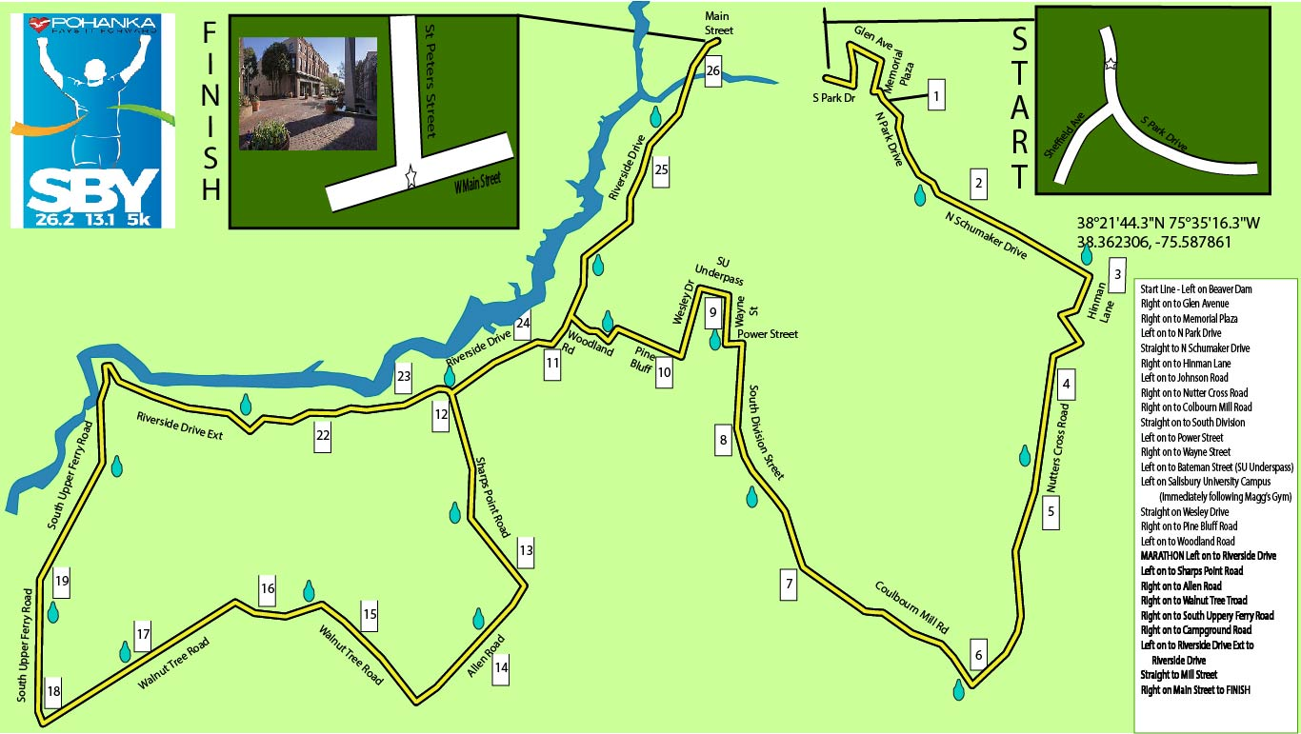

We sincerely appreciate your patience and, most of all, your watchfulness as you drive in and around Salisbury this coming weekend. For more information on routes or the SBY Marathon in general, go to www.sbymarathon.com

###

